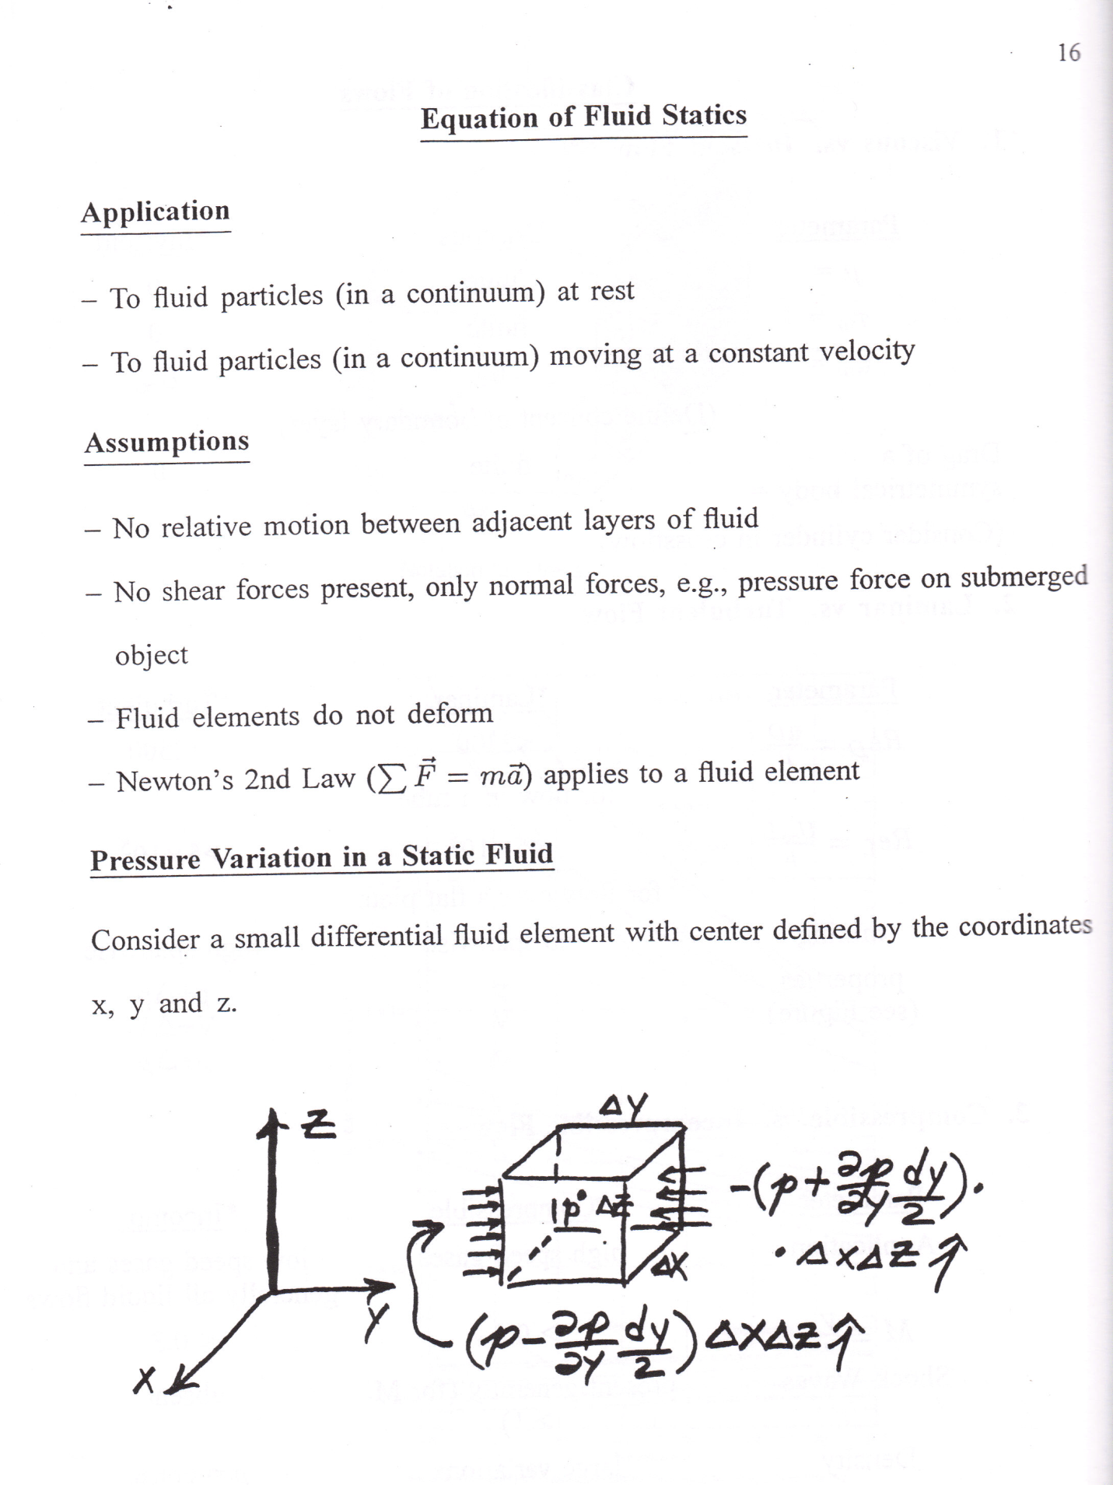

1. To fluid particles moving at constant velocity
2. To fluid particles at rest
3. No slip condition (fluid layers have no motion relative to themselves)o fluid particles at rest
4. Fluid does not deform
5. Newton’s 2nd Law
6. No shear stresses present (Only normal forces) [principal stresses????]

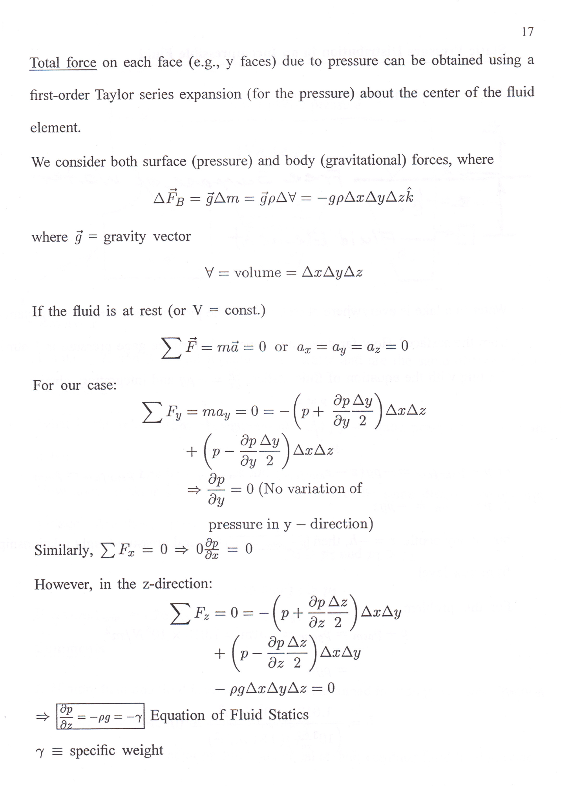

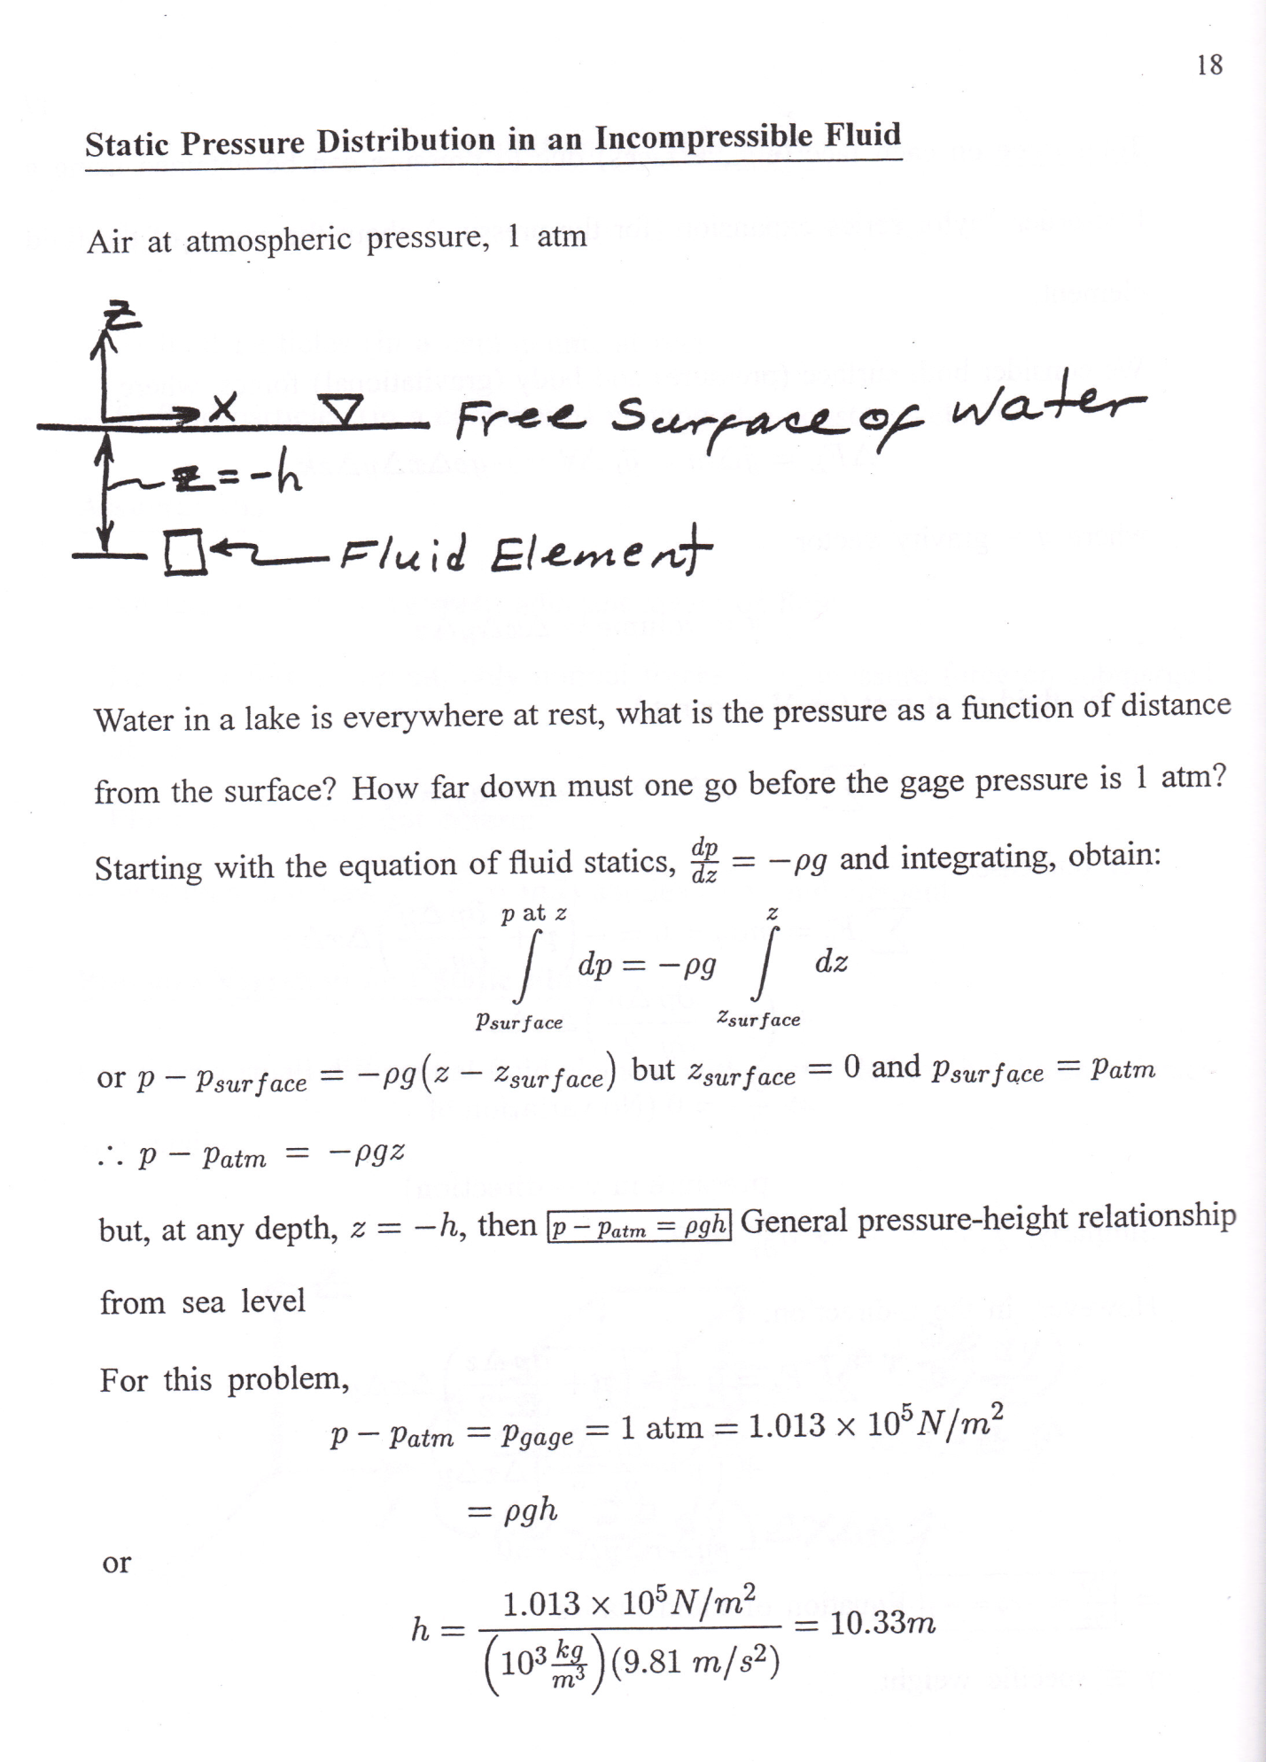

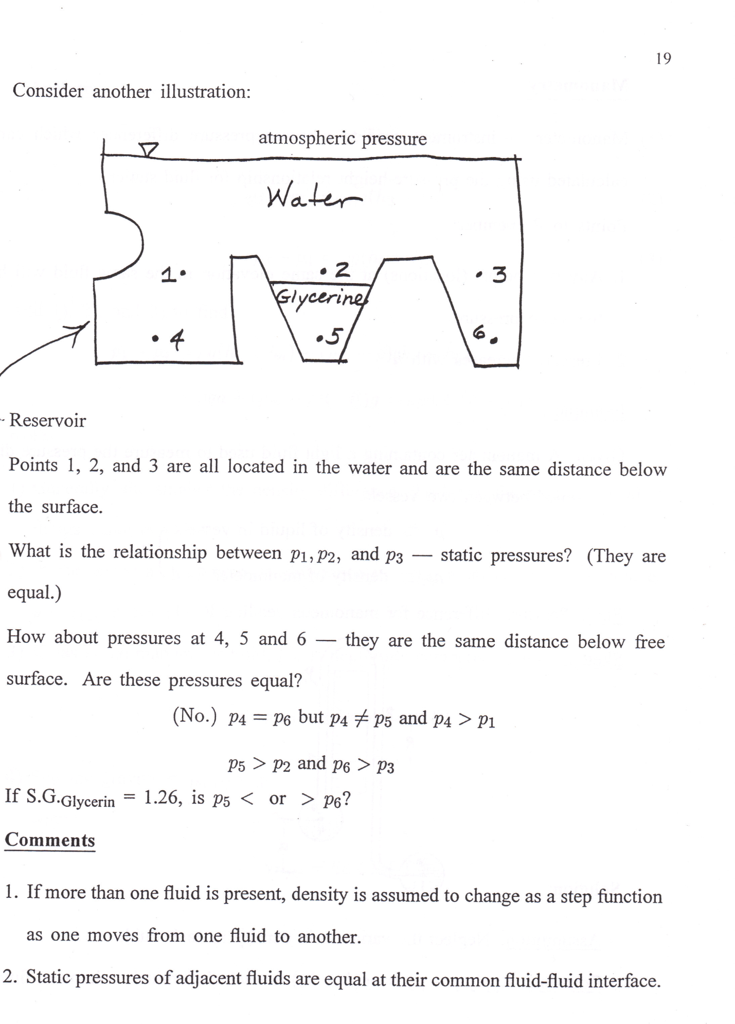

1. Pressure at same elevation for same fluid is equal

Newton’s 2nd Law

1. Density changes as a step function at the fluid interface (in other words we assume constant density for each different type of fluid in the container)